

**SECP1513-TECHNOLOGY AND INFORMATION SYSTEM**

**ASSIGNMENT:**

**PROJECT DESIGN THINKING**

SECTION : 08

LECTURER NAME : DR. SURIATI BINTI SADIMON

| NO. | NAME | MATRIC NUMBER |
| --- | --- | --- |
| 1. | BALQIS BINTI MOHD SARMIZI | A24CS0053 |
| 2. | NURUL ATHIRAH BINTI ZAKARIA | A24CS0175 |
| 3. | CHOONG SIN QI | A24CS0236 |
| 4. | SITI ATHIRAH BINTI ABD MALIK | A24CS0189 |
| 5. | YEO LING | A24CS0314 |

**Table of contents**

| **Contents** | **Pages** |
| --- | --- |
| Introduction | 3 |
| Log journal | 4 |
| Brainstorm | 5 |
| Problem and solution | 6-7 |
| Team working | 8-10 |
| Evidence | 11-21 |
| Reflection | 22-26 |
| Conclusion | 27 |
| References | 28 |

**Introduction**

**About our mobile app:**

*Feast Finders* is an ultimate app for making healthy eating easy and dining fun. It meets the requirements for those people who look forward to sticking to their health goals without having to compromise on trying a variety of food options. The calorie calculator will come in handy, and the nutritional details will provide all the necessary calories, macronutrient breakdowns, dietary suitability for low-carb, gluten-free, plant-based, or allergen-free options. It will also make personalized meal suggestions according to personal preferences and previous choices. Other accessories include a Daily Intake tracker, setting goals, and nutrition-related progress trackers that will allow the user to adopt a healthier approach to life. Feast Finders make dining out an educated, satisfying, healthy experience. All in all, it's just more comfortable to eat healthy and be on target to reach your aims.

**Objective and Overview:**

This project aims to develop a food discovery app that helps users make healthier and informed dining decisions. The app tackles challenges like finding meals that fit specific diets or health goals by offering detailed nutritional information, including calorie counts, macronutrient breakdowns, and dietary filters like gluten-free or plant-based options. It provides personalized meal recommendations based on users’ preferences and restrictions, making it easy to discover enjoyable meals. Social features let users follow restaurants, share meal photos, and explore trending dishes. With tools to track intake, set goals, and monitor progress, the app promotes healthier habits. By addressing unmet expectations, poor food choices, and food waste, it transforms dining into a more informed, enjoyable, and health-conscious experience, encouraging better eating habits and sustainable living.

**Log journal**

| Date | Description |
| --- | --- |
| 11 November 2024 | - Discussion about the project ideas.  - Distribute tasks to each group member. |
| 12 November 2024 | - Create a slide for a rough idea |
| 13 November 2024 | - Present rough ideas to the class  - Modify ideas based on the lecturer’s comments |
| 24 November 2024 | - Confirm main ideas  - Collect all information regarding the project |
| 13 December 2024 | - Start making reports |
| 17 December 2024 | - Finalize features and make a prototype |
| 25 December 2024 | -Start making video and presentation |
| 13 January 2025 | -Finalize report, video, and presentation |
| 14 January 2025 | - Ready to submit |

**Brainstorming ideas**



**PROBLEM AND SOLUTION**

| Problem | Description | Solution |
| --- | --- | --- |
| Limited idea of project | Firstly, our thought was limited to only serving UTM students with food from UTM eateries, but after reviewing the initial concept, the decision was made to expand the app into a more comprehensive platform, combining food discovery,education, and social interaction. We want to make apps different from other apps, like Grab, MISI and so on. The original app concept lacked interactive features such as opportunities for people to share their food experiences, explore new restaurants, or learn about the nutritional value they were consuming. At initial idea, we only focused on food delivery on UTM campus only and ordering, it didn’t include such a feature as mentioned earlier, which made the app lack engagement . | It's a new edition of application with an entirely different set of cool features. The application was totally about food discovery and helped people discover food at new places to eat. It may be restaurants, dishes, or whatever unique food experience one would not like to miss with this app while finding his/her cravings for food or something entirely new.  From thousands of food options, restaurants, and food places around the corner, this app lets one search for everything.  And to make it more entertaining, we have added social features: the possibility for a user to follow their favorite restaurants and keep up with what they're offering, sharing photos of meals, and even see what other people are eating. It's like building a food community where everybody shares recommendations, experiences, and their favorite dishes. There is also a social feed showing what is trending, where your hidden gems are, and sharing with others who love food. It's way more than just a restaurant guide; it connects people with food, turning every meal into an opportunity to explore and share. |
| Lack of knowledge about food | Many people are unaware of what they are ordering, leading to unmet expectations, dissatisfaction, and food waste. This lack of information about the flavour, ingredients, and suitability of meals can result in users wasting food and money. | Our app solves the problem of people not knowing what they’re ordering by giving them all the details they need. Each dish has a description of its ingredients, flavors, and how it’s prepared, so users know exactly what they’re getting. There are also real photos shared by other users, so you get a clear idea of the portion size, how it looks, and what to expect. On top of that, the app includes honest reviews and ratings from the community, which helps users figure out if a dish is right for them. There are also filters for allergens and dietary needs, so users can easily find meals that suit their requirements. Plus, the app gives personalized recommendations based on past orders and preferences, helping users choose something they’ll love. With all this information, users can make better decisions, which means less food waste and no money spent on something they won’t enjoy. |
| Struggle of finding healthy and diet-specific meals when going out | A lot of people have trouble finding healthy food options that match their specific diet needs when eating out. With so many choices out there, it’s hard to know which meals are really healthy or fit into things like a low-carb, gluten-free, or plant-based diet. This lack of clear info can lead to people eating food that’s not good for them, which can mess with their health goals and cause frustration. On top of that, without knowing the nutritional details, it’s hard for users to make informed decisions, which can lead to poor eating habits, weight gain, or even health problems. It’s especially tricky when eating out, since the options are often confusing or not well explained. | To solve the problem of finding healthy meals that fit specific diets, this app adds a calorie and nutrition calculator. This tool breaks down each dish, showing you things like calories, carbs, proteins, fats, and important vitamins and minerals. It makes it super easy to see if a meal fits into your health goals, whether you’re trying to lose weight, build muscle, or just eat balanced meals.  On top of that, the app tells you if the dish is low-carb, gluten-free, dairy-free, plant-based, or free from common allergens. This way, you don’t have to guess whether a meal fits your diet—you’ll know right away if it’s a good choice. The app also suggests personalized meals based on what you like to eat, your health goals, and any dietary restrictions you have. It learns from your past orders and preferences to recommend meals that you’ll enjoy and that fit your diet, making it easier to stay on track while dining out.  You can even track your daily intake, set goals, and see your progress. This helps you stay focused on your nutrition, so you’re less likely to overeat or pick something that doesn’t work for you.  With this solution, you can make healthy choices without all the guesswork, stay on top of your diet, and enjoy eating out without worrying about whether your meal fits your health goals. |

**Team working**

To ensure an effective collaboration, our team has to establish a unified vision for the app. Hence, we have had several face-to-face meetings to collect and integrate teammates' opinions. Teammates readily spare their time to be involved in the meeting and actively generate innovative ideas during the discussion. We mostly discuss our project framework through WhatsApp to foster more flexible communication and manage differing free time.

Team members have been assigned tasks based on their capabilities. Balqis, Athirah and Sin Qi mainly worked on the content of the report and discussed the prototype of the foodie app. Likewise, Siti and Yeo Ling mainly concentrated on the creation of the app's user interface and the interview and production of the video. Our team members communicate sufficiently to ensure our outcome is related and connected well although working on different parts of the assignment.

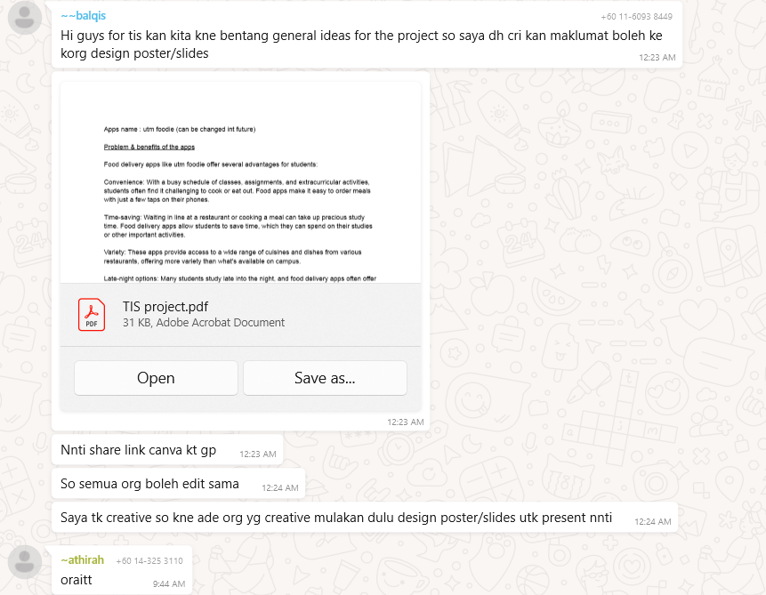

Figure 1.0 Generate idea

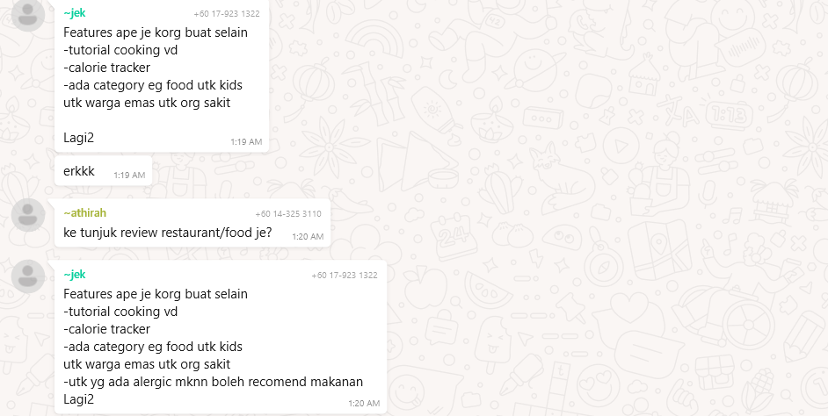

Figure 1.1 Derive ideas

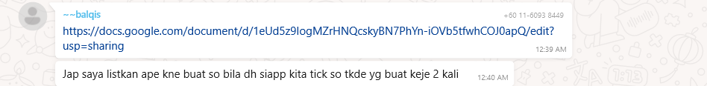

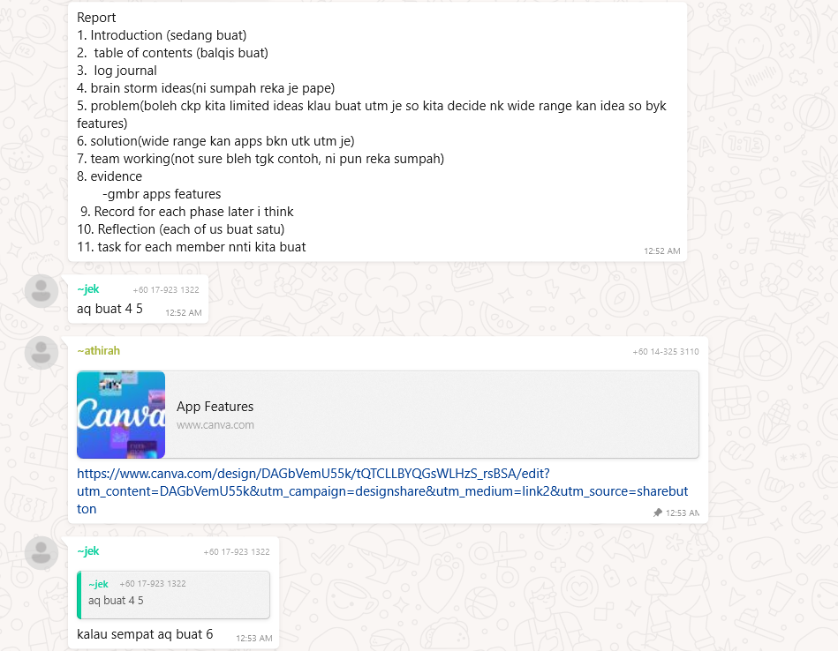

Figure 1.2 & Figure 1.3 using collaborate tools to cooperation and divide task

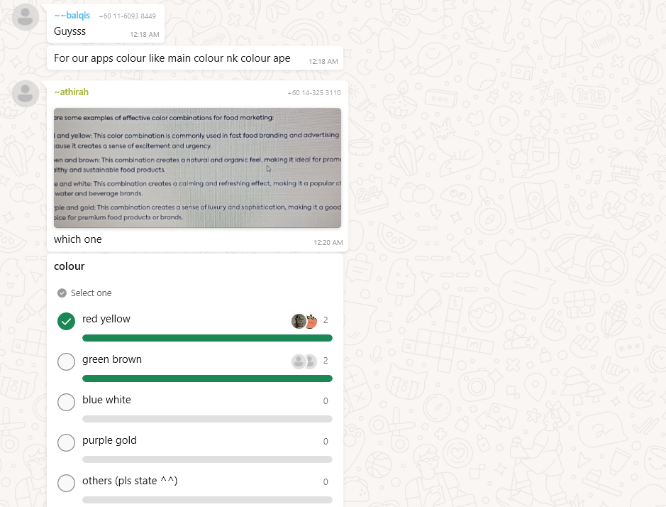

Figure 1.4 Discuss for convinced decision

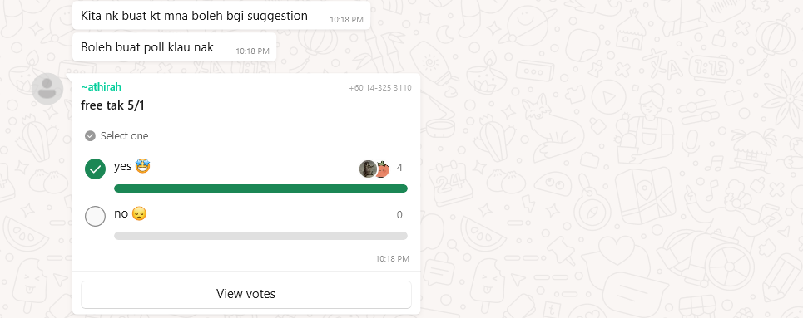

Figure 1.5 Meet for idea discussion and prototype making

**Design thinking evidence**

**Empathy phase**

We generate a survey using Google Forms to get more information from a wider range of people.

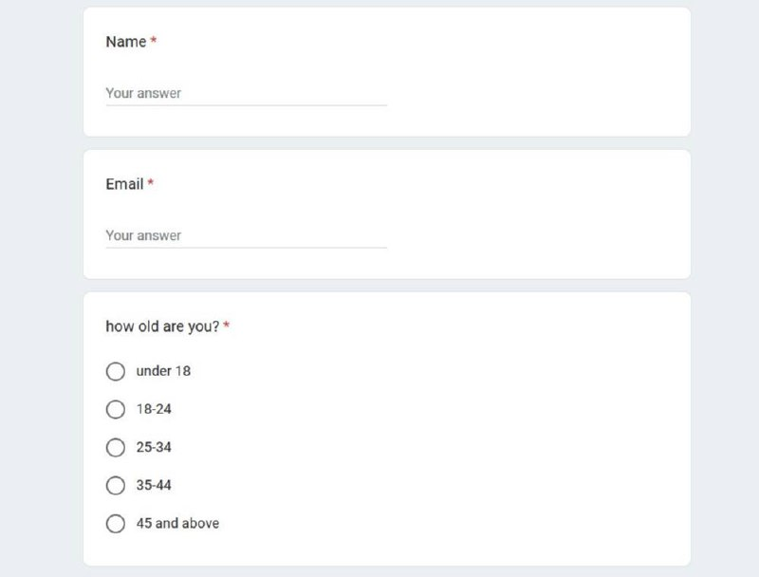

Figure 2.0

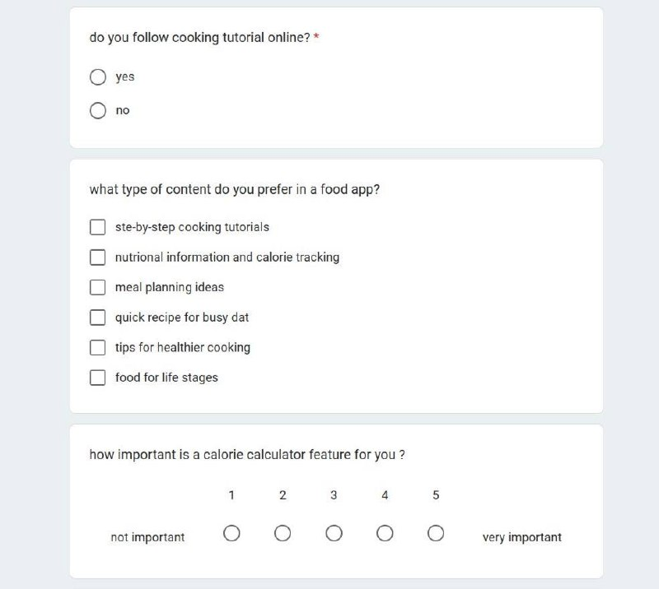

Figure 2.1

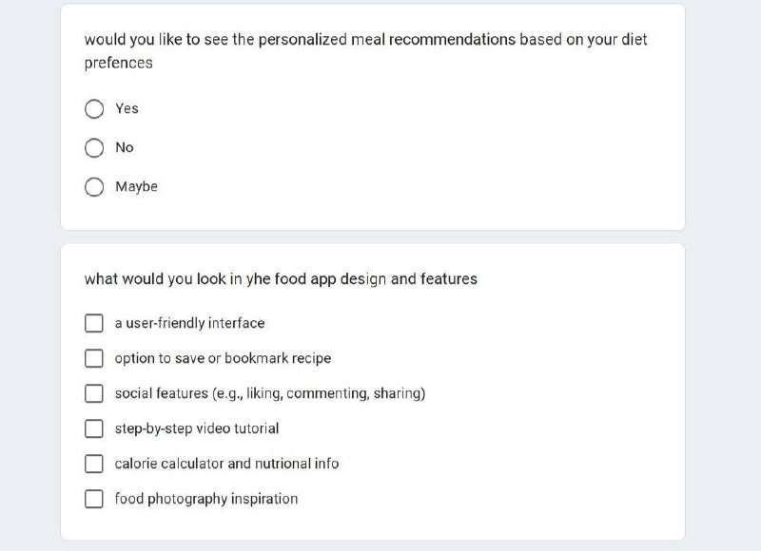

Figure 2.2

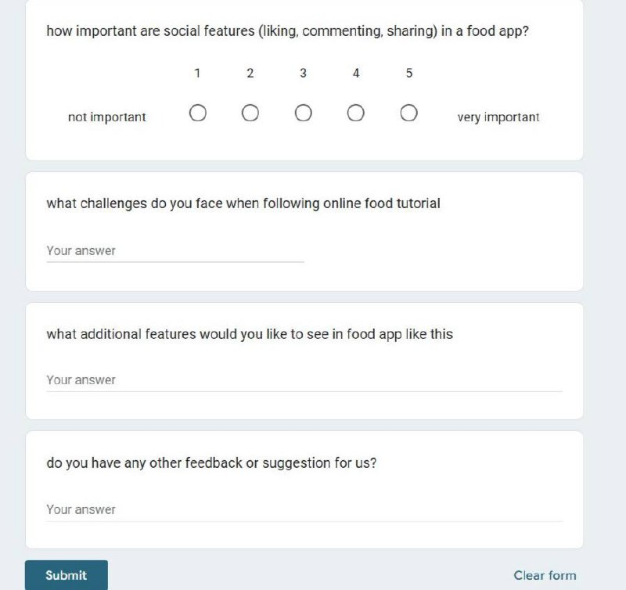

Figure 2.3

We also interviewed a person who uses food apps.

Here are some of the questions that we ask :

1. What food apps do you usually use?

Respondent: Foodpanda

2. What feature do you like the most in the apps and why?

Respondent: I like the real-time tracking which we can track our order on the apps

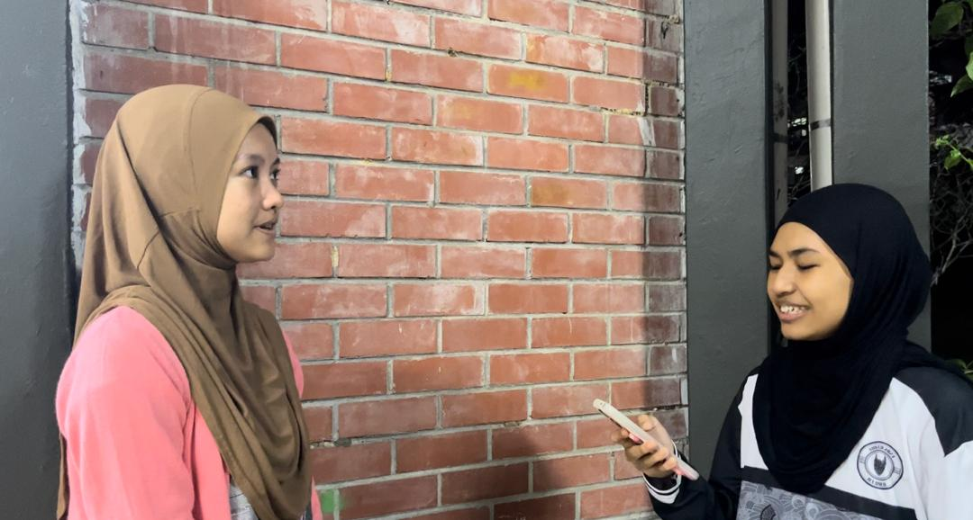

Figure 2.4

**Define phase**

The define phase is where we accumulated all the information obtained from the interviews as well as the Google Form. The result allowed us to analyze and understand the problem faced by users better so we could come up with solutions that meet their needs.

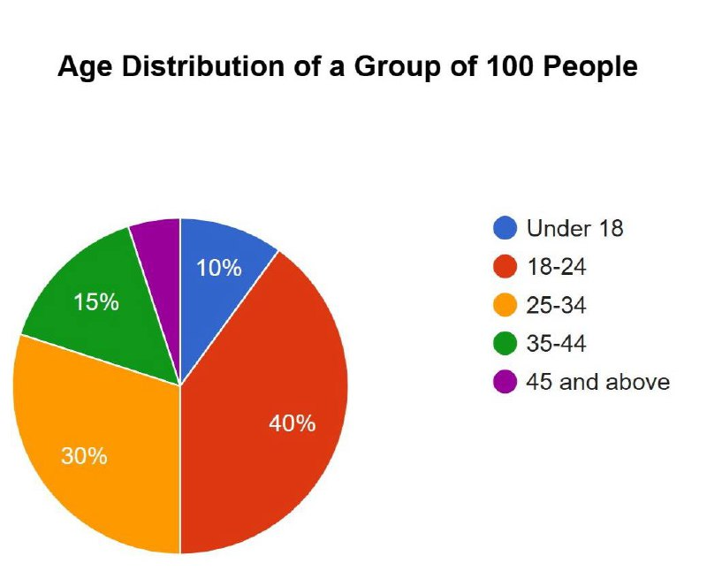

Figure 3.0

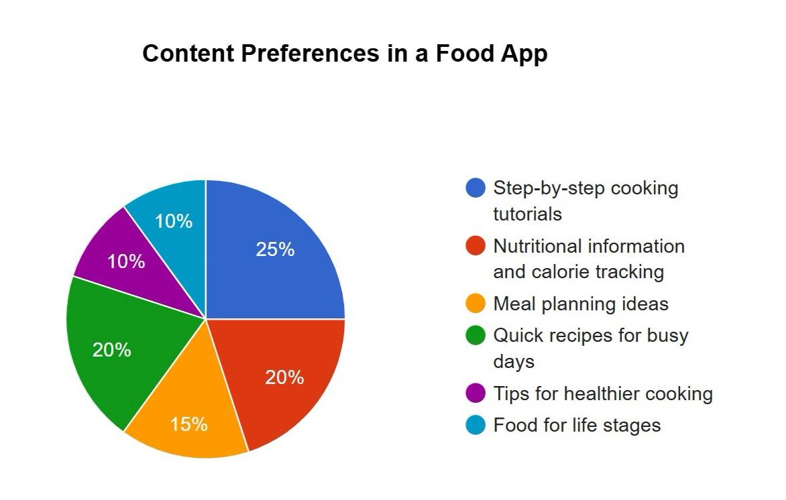

Figure 3.1

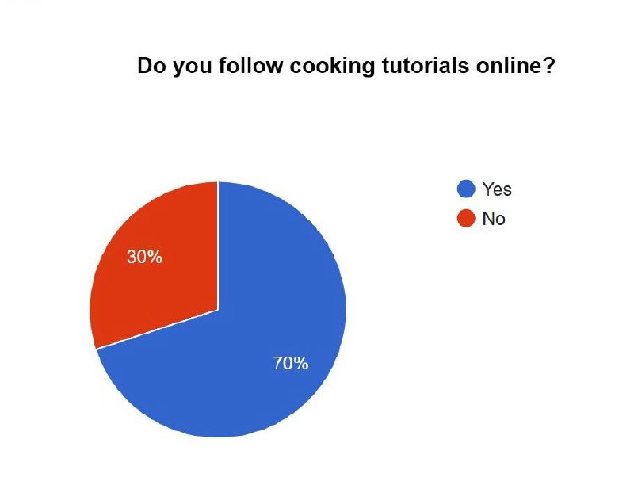

Figure 3.2

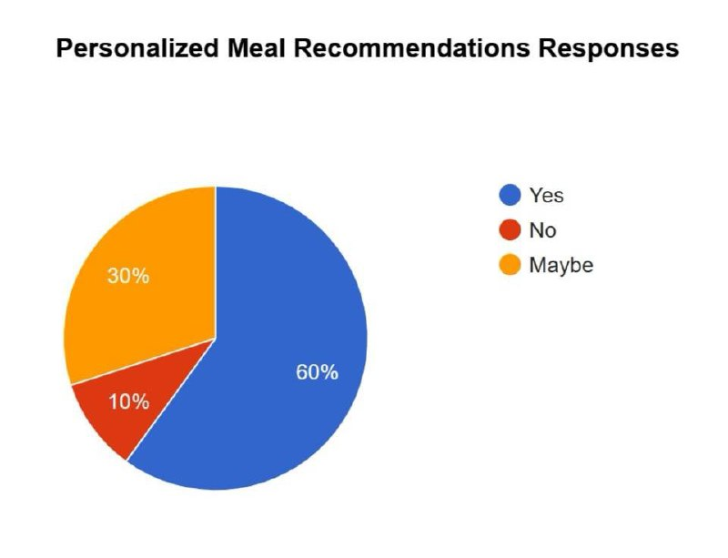 figure 3.3

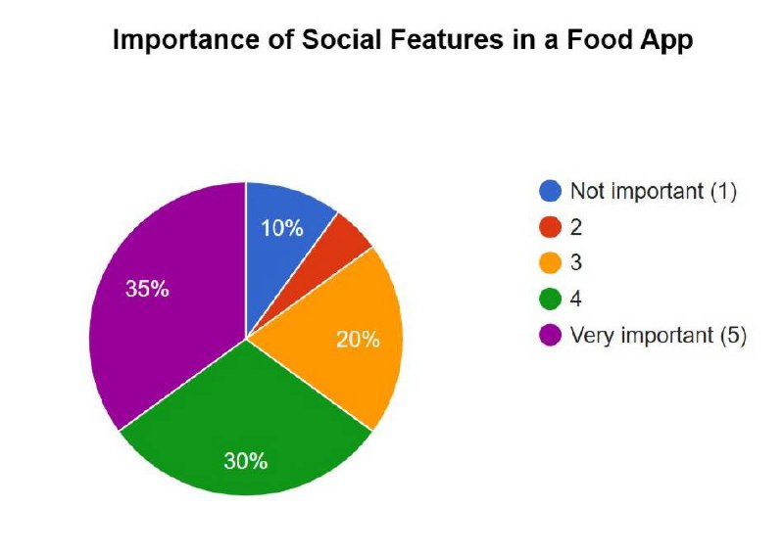

Figure 3.4

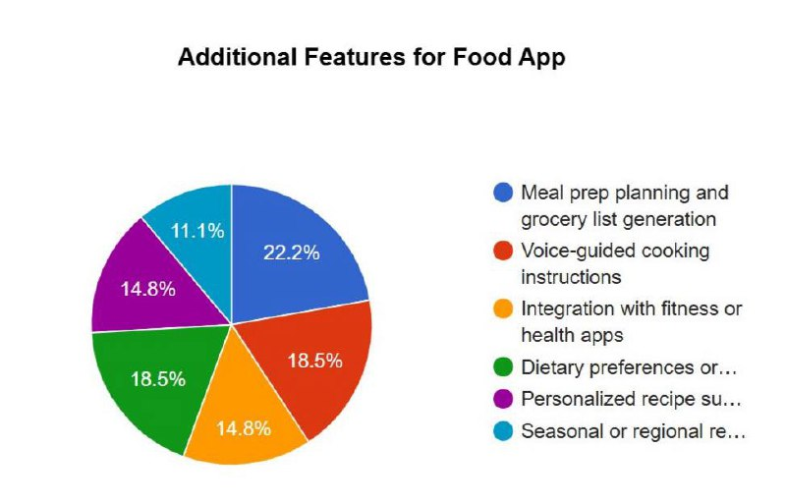

Figure 3.5

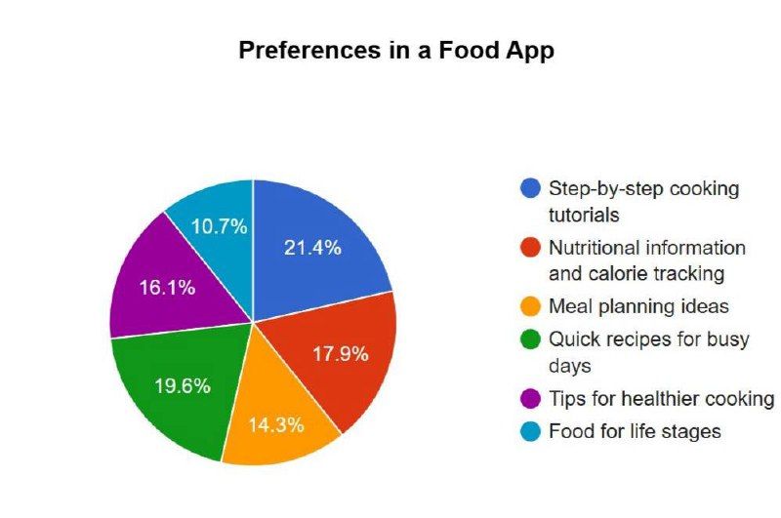

Figure 3.5

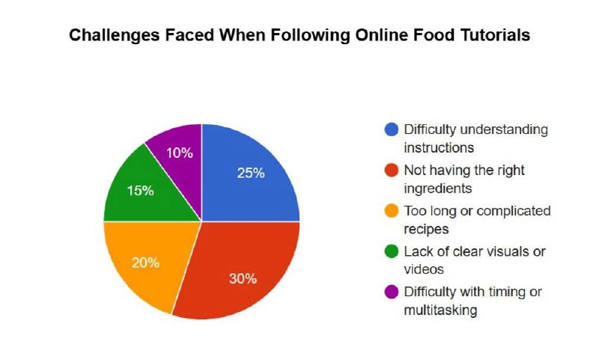

Figure 3.6

**Ideate phase**

During the ideate phase, our team discusses finding the most efficient solution to the problem presented to us from the result above. We came up with the solution to implement the Feast Finder, an intuitive application designed to help users easily make by themselves or food outlets based on their preferences and dietary needs.

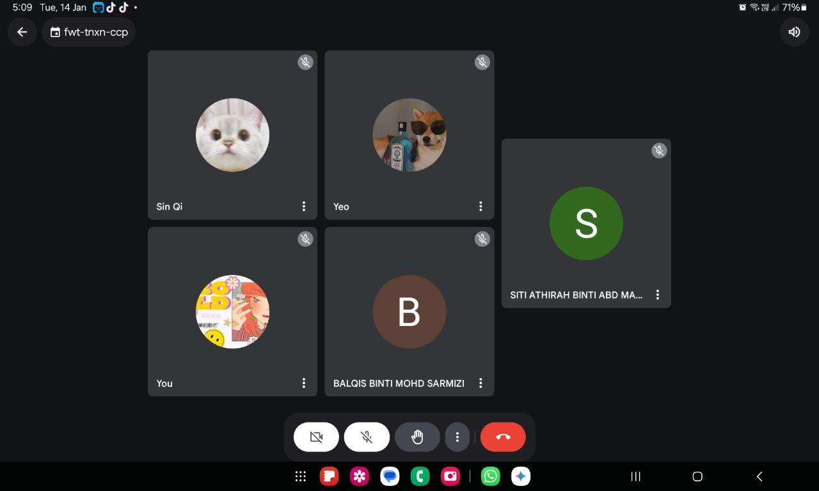

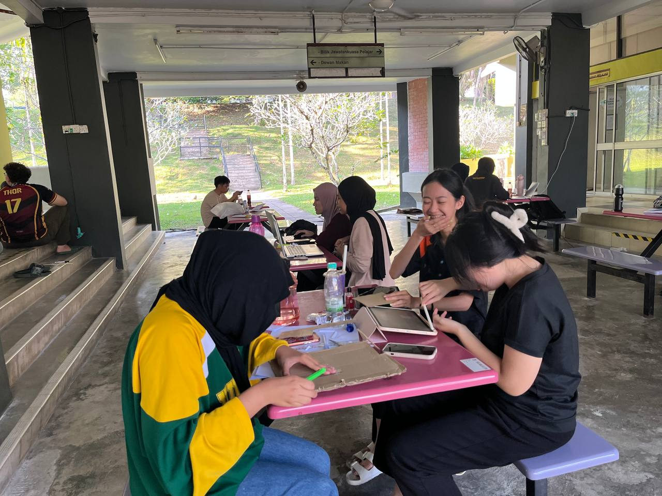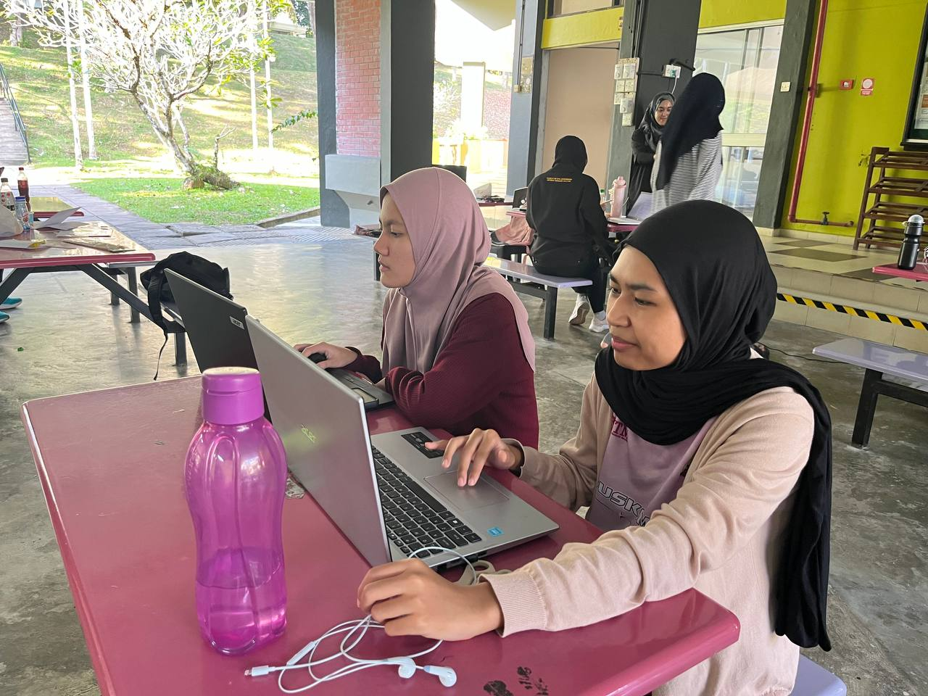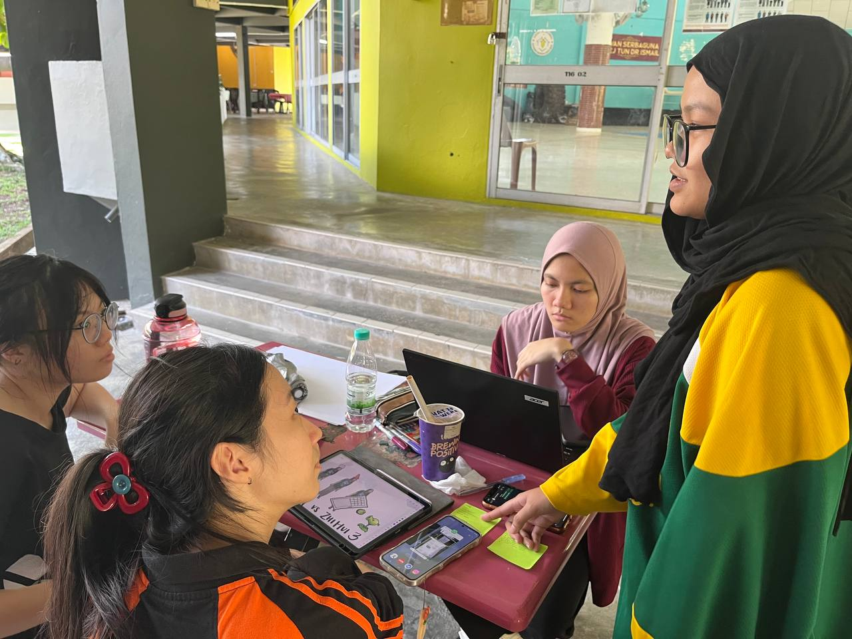

Figure 4.0 Group meeting during ideate phase

**Prototype Phase**

During the prototype phase, we created a prototype of the tool mentioned during the ideate phase based on the results from the define phase. The prototype is shown below: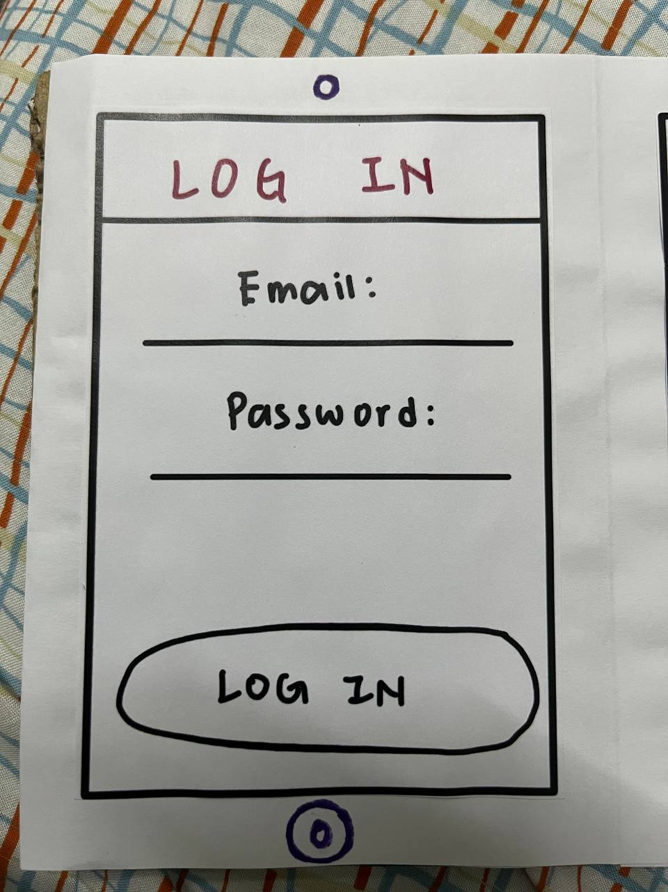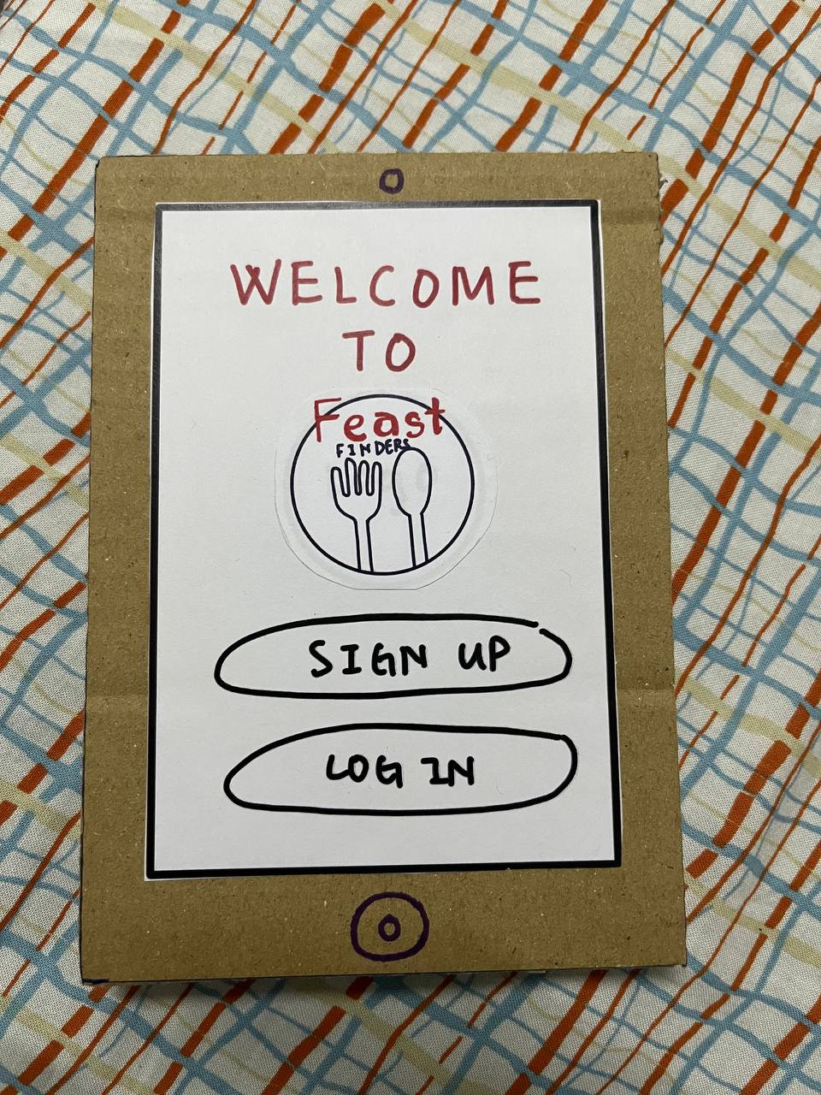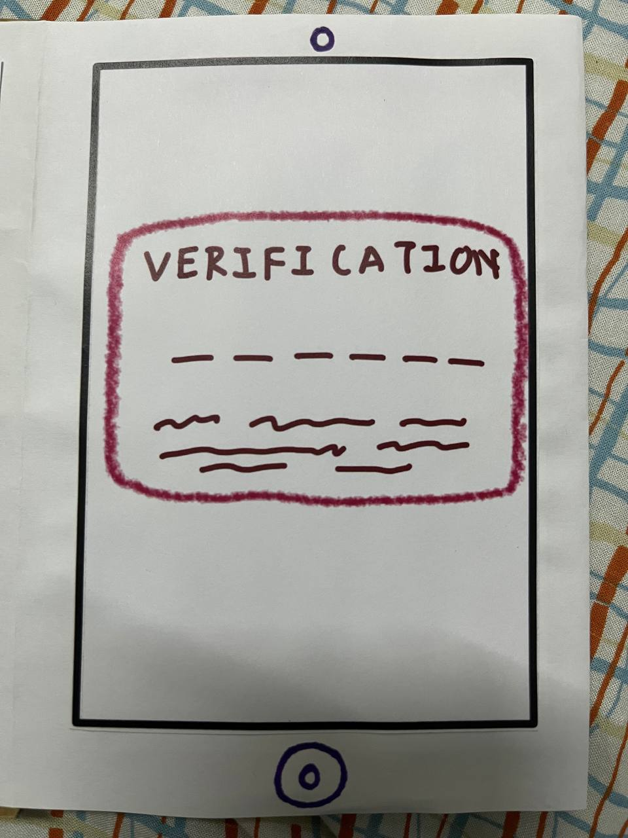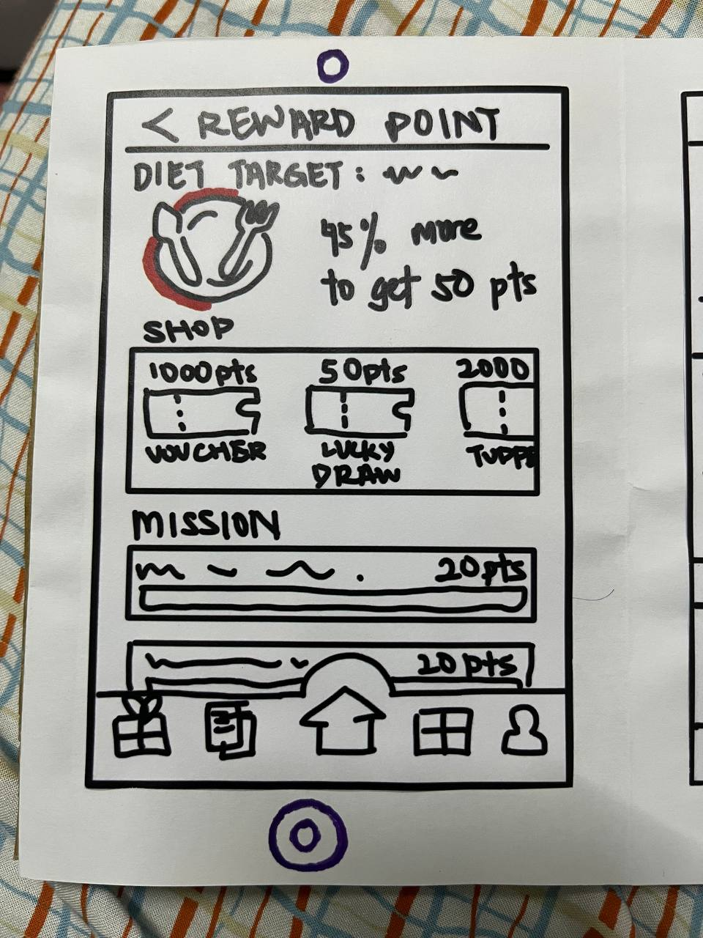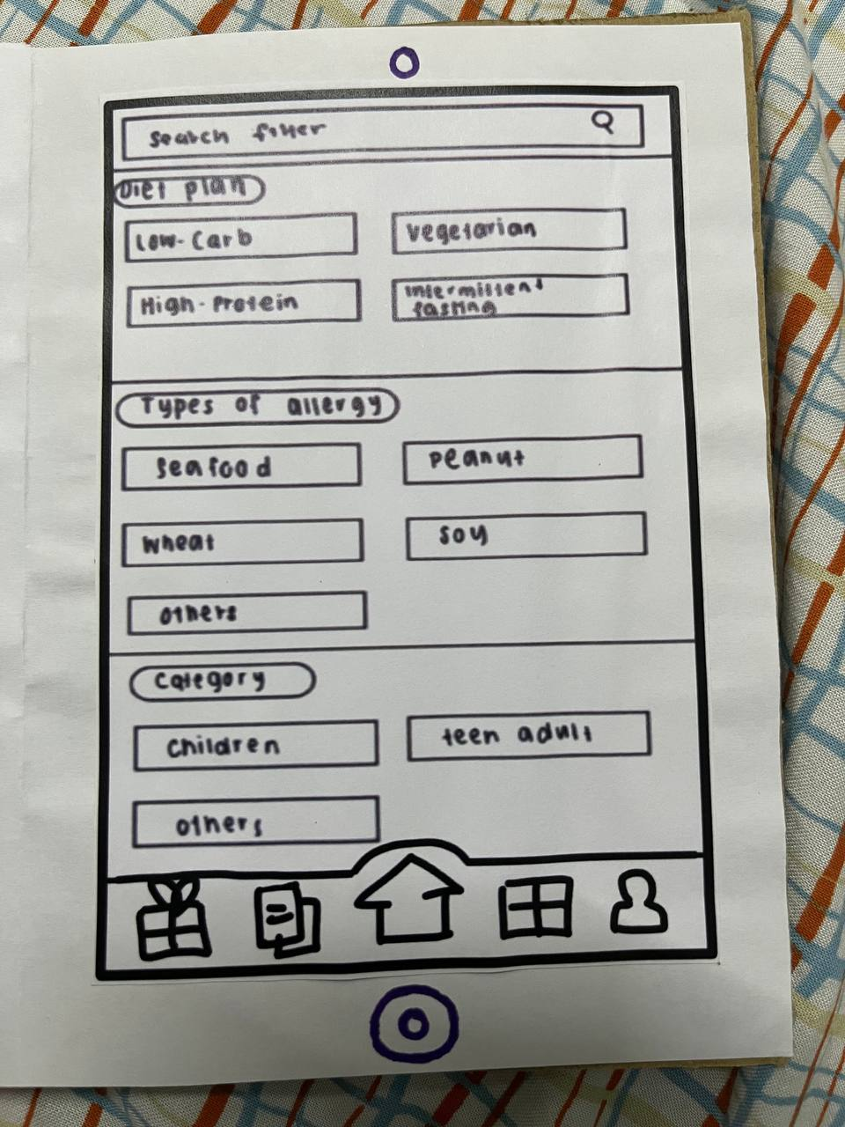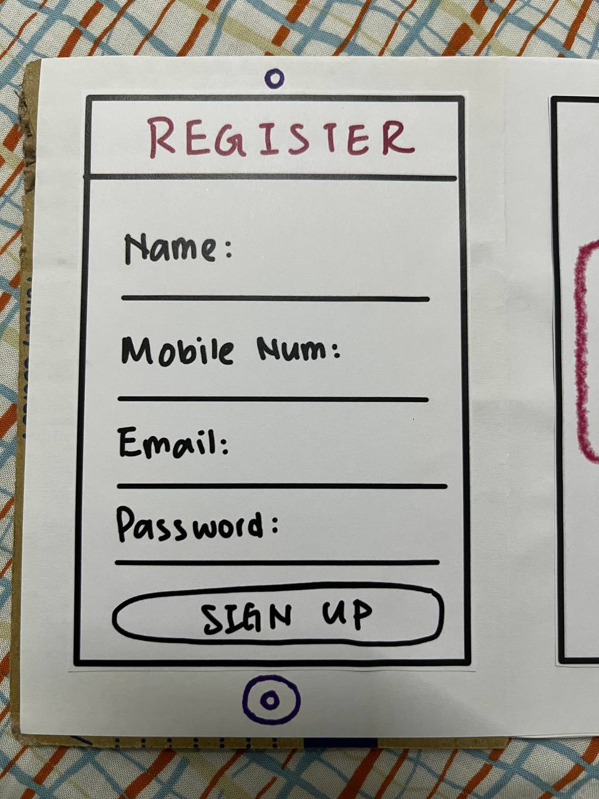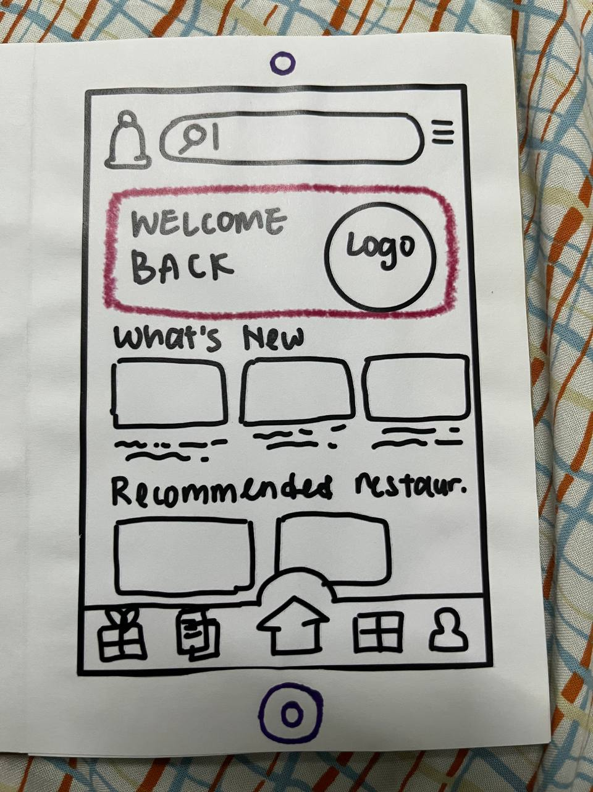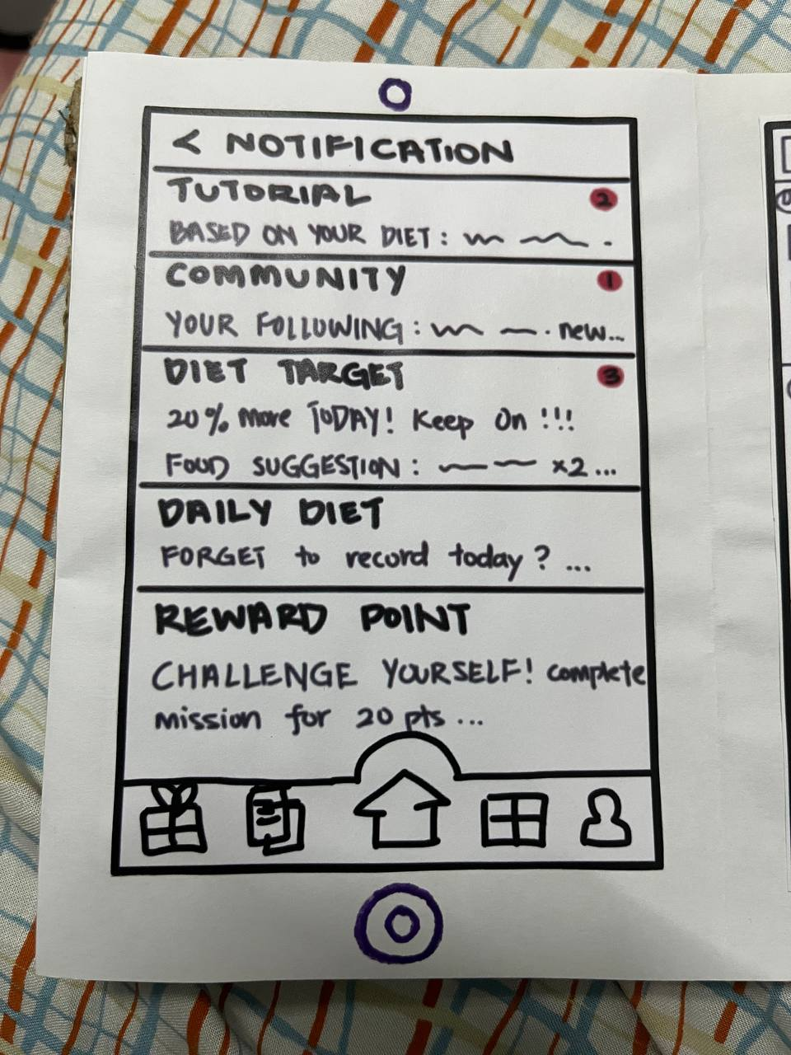

**Prototype Testing Phase**

During the prototype testing phase, we had users try it out and share their thoughts. They gave positive feedback, were impressed with how it worked, and appreciated the design and the features. Their reaction showed the prototype met their expectations and made a great impression.

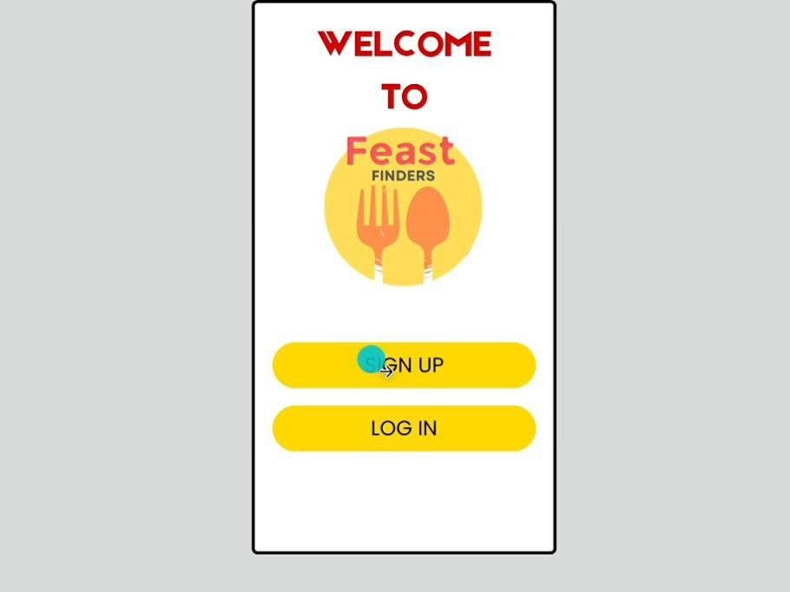

Figure 6.0: Testing the prototype (Digital Version)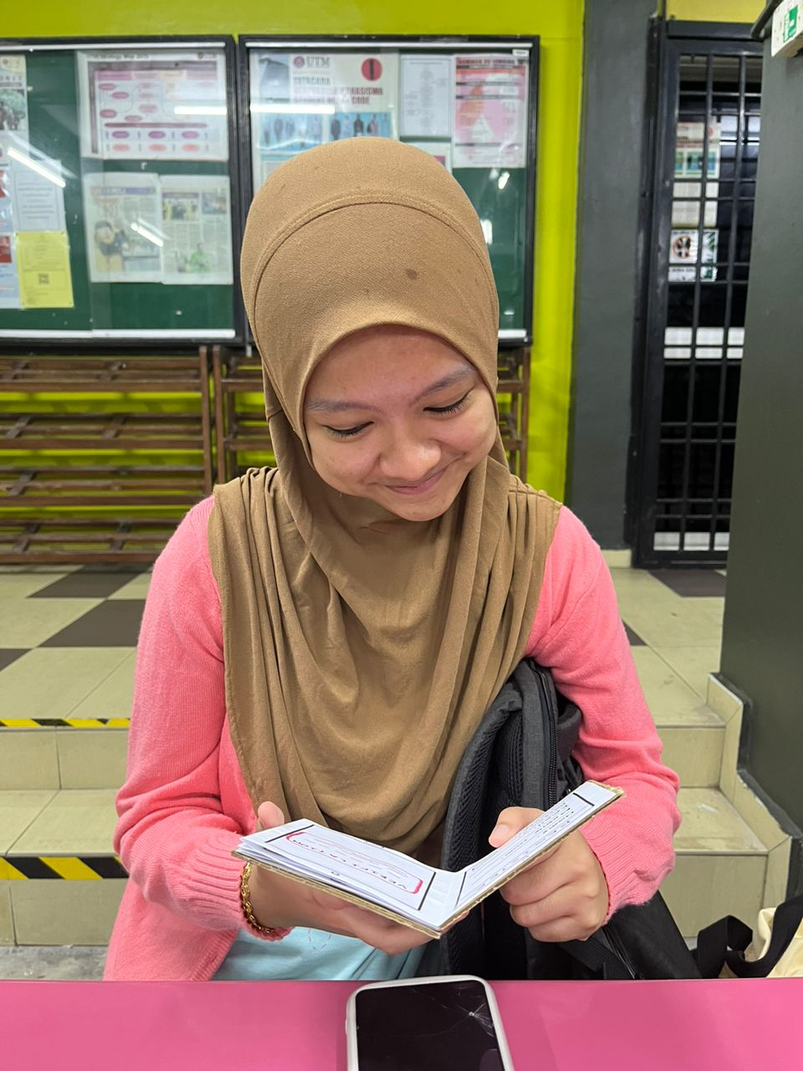

Figure 6.1: Testing the prototype (Physical Version)

**REFLECTION**

**BALQIS BINTI MOHD SARMIZI :**

1. What is your goal/dream with regard to your course/program?

I aim to be highly skilled in creating innovative, visually appealing projects. I dreamed of becoming a web designer as I could apply all the skills that I learned in university.

1. How does this design thinking impact on your goal/dream with regard to your program?

It has very well influenced my goal. It teaches me to look at things through the user's eyes regarding challenges. In graphics and multimedia software, it would mean building aesthetically engaging but almost intuitive applications, so that the user power is user-friendly. I keep iterating and testing with feedback on whether designs adhere to user needs effectively.

1. What is the action/improvement/plan necessary for you to improve your potential in the industry?

To improve my potential in the industry, I plan to enhance my programming skills in languages like C++, Java, Python, and more. I also want to gain experience by doing internships in relevant industries to gain hands-on experience.

**NURUL ATHIRAH BINTI ZAKARIA :**

1. What is your goal/dream with regard to your course/program?

I am driven to become a skilled and innovative professional in computer science, with a passion for using technology to solve real-world challenges and improve lives. I aim to work on cutting-edge applications, particularly in artificial intelligence, machine learning, and data analytics. My vision is to design systems that simplify decision-making, optimize resources, and deliver personalized experiences. Ultimately, I aspire to contribute to impactful, large-scale tech projects that shape the future of the industry and leave a lasting global legacy.

1. How does this design thinking impact on your goal/dream with regard to your program?

Design thinking has completely changed how I approach problems and solutions, especially in technology. Rather than jumping straight into building something, it encourages me to step back, understand the user's needs, and identify the root cause of their problems. This mindset is crucial to achieving my goals because it ensures that the solutions I create are not only functional but also relevant, user-friendly, and impactful. For example, if I were to develop a food-related app, I wouldn’t just create a standard recipe app. Using design thinking, I would first explore what users truly need: maybe they struggle to find recipes based on limited ingredients, or perhaps they want an app that offers dietary advice alongside recipes. I would then ideate and prototype different solutions, test them with users, and refine the design based on feedback. This approach ensures that the end product is more meaningful and practical, helping me work towards my goal of creating impactful technology.

1. What is the action/improvement/plan necessary for you to improve your potential in the industry?

Some improvements are necessary to improve my potential in the industry. Firstly,

I should improve my work ethic and show more responsibility, reliability and discipline in my team or personally. Therefore, people will see a positive attitude that enhances my potential in the industry. After learning the experience from this project, I realised that improving organisation skills also play an essential role in enhancing my potential in the industry. As a person who obtained organisation skills, good organisation skills come with a good time and task management that help increase the work's efficiency and effectiveness. Hence, other people can see my contributions through my productive performance with sharp organisation skills. In short, I believe that work ethics and organisation skills will be the necessary improvement for me to improve my potential in the industry.

**CHOONG SIN QI :**

1. What is your goal/dream with regard to your course/program?

My objective for the course in Technology and Information Systems is to create innovative technological solutions that could improve the quality of people's lives. Eventually, I hope to be someone who is skilled enough to create and develop powerful applications and systems that will bring about effective change. I want to work on those projects that make tools for bridging convenience with self-improvement, making it possible for their users to make healthier, more informed decisions about their lives and productivity.

1. How does this design thinking impact on your goal/dream with regard to your program?

The design thinking allowed me to instigate creativity from a user perspective, and this aligns well with my ambition to design practical applications. Besides, I have learned to consider the empathy, ideation, and prototyping stages, which enables me to build user-centric solutions. For example, the foodie app that I came up with-it is a combination of a cooking and calorie tracking app, aimed at encouraging users to make self improvement. That is what I strive for when I design a tech solution, it could encourage self development in addition to offering modern easy needs.

1. What is the action/improvement/plan necessary for you to improve your potential in the industry?

To improve my potential in the industry, I would make an effort to improve my programming and app development skills as well as strengthen my knowledge in advanced technologies. I would also be attending various conferences and exploring professional social networks to understand the industry ecosystem better. Furthermore, I hope to put my learning into practice and gain practical experience by working in multicultural teams. Not only that, I would improve my ability and proficiency by continuing learning through online courses, certification and industry resources.

**SITI ATHIRAH BINTI ABD MALIK :**

1. What is your goal/dream with regard to your course/program?

My objective for this program is to make the world better. In this modern world, I can improve accessibility through technology. By developing easy-going tools such as AI-powered features and voice recognition, we can assist people with disabilities to direct them in the digital landscape with ease. In addition, developing technology that closes the digital barrier guarantees that everyone has equal access to technology no matter what their socioeconomic status or where they are.

1. How does this design thinking impact on your goal/dream with regard to your program?

This design thinking does impact my goal because this app has a user friendly interface, meaning easy-to-read interfaces. The app fulfils the needs, such as offering features for people with dietary restrictions or people with allergies. This app has the potential to transform the way people connect with food, making it more healthier, customized to individual needs.

1. What is the action/improvement/plan necessary for you to improve your potential in the industry?

The improvement that I need to build on my potential in the industry is I need to practice my programming skills often or learn new tools and technologies. I also need to stay updated on trends like artificial intelligence and cybersecurity. Besides that, it is required for me to do networking as I can connect with people that are experts in this industry. I am able to learn some skills from them.

**YEO LING :**

1. What is your goal/dream with regard to your course/program?

My goal in Technology and Information Systems is to become a professional who can design and manage innovative IT systems that solve problems. I aim to grow in areas like cybersecurity, data analytics, and system integration to create effective solutions that help businesses and communities. I will use the knowledge in TIS to develop systems that improve accessibility and support local businesses.

1. How does this design thinking impact on your goal/dream with regard to your program?

Our project in design thinking has aligned with my objective of being an advanced professional in Technology Information Systems because the app solves real-world challenges through system design, data analytics, and user-driven innovation that promote healthy lifestyles and informed decision-making. It fills in the gaps for dining options by offering transparency and catering to diverse dietary needs. This project shows my commitment to crafting intelligent, effective solutions and demonstrates the transformative potential of TIS in improving individual and community well-being.

1. What is the action/improvement/plan necessary for you to improve your potential in the industry?

I plan to further my studies in cybersecurity, data analytics, and system integration through research, workshops, online courses, and expert consultation. In addition, I will also take experience from internships and projects that will help me apply theory to practice effectively. In the future, I will look forward to certifications such as CISSP and CompTIA Security+ to enhance technical skills. It helps me in developing innovative IT solutions to real-world challenges.

**Conclusion**

The Feast Finders app has solved the problems of nutritional awareness, meal options with diet-specific needs, and unmet expectations through easy, healthy eating. It allows users to make smart dining decisions through personalized recommendations, calorie tracking, and social engagement.

It actually was a really collaborative process, putting the feedback of the users in front and using design thinking. The final solution is rather practical, making quite a difference. Feast Finders make dining healthier and better informed, let alone fun, showing how technology can improve people's everyday life.

**References**

# 

Case-Lo, Christine. “Food & Nutrition.” *Healthline*, 2017, www.healthline.com/health/food-nutrition.

Cleveland Clinic. “What Are Macronutrients and Micronutrients?” *Cleveland Clinic*, 5 Oct. 2022, health.clevelandclinic.org/macronutrients-vs-micronutrients.

“Food Preference - an Overview | ScienceDirect Topics.” *Www.sciencedirect.com*, www.sciencedirect.com/topics/medicine-and-dentistry/food-preference.

“How to Set up a Food Business Website?” *Unilever Food Solutions UK*, www.unileverfoodsolutions.co.uk/chef-inspiration/food-service-and-hospitality-marketing/digital-marketing-for-restaurant-owners-and-chefs/how-to-set-up-a-website-for-your-food-business.html.

“Nutrient Information Inquiry.” *Cfs.gov.hk*, 2017, www.cfs.gov.hk/english/nutrient/nutrient.php.

Scribbr. “What Is Academic Writing? | Dos and Don’ts for Students.” *Scribbr*, 2022, www.scribbr.com/category/academic-writing/.

WebMD. “Food Calorie Counter & Calculator.” *WebMD*, 2018, www.webmd.com/diet/healthtool-food-calorie-counter.